Create the component for book detail in the components section.

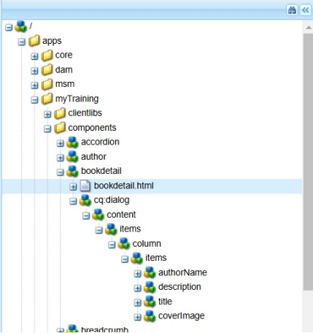

Create the html file which is used to display the book’s detail.

Create a template for the books in AEM with custom header and footer.

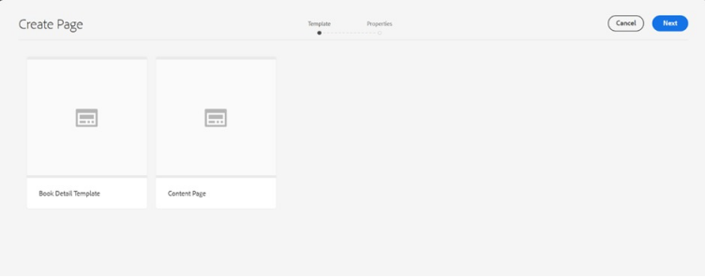

List of pages .create as many as required.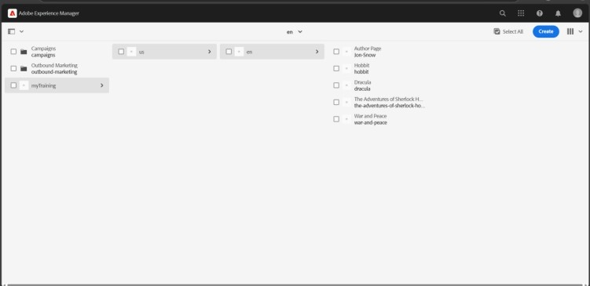

Header

C:\Users\User\AppData\Local\Microsoft\Windows\INetCache\Content.MSO\7C589127.tmp

Book page creation:

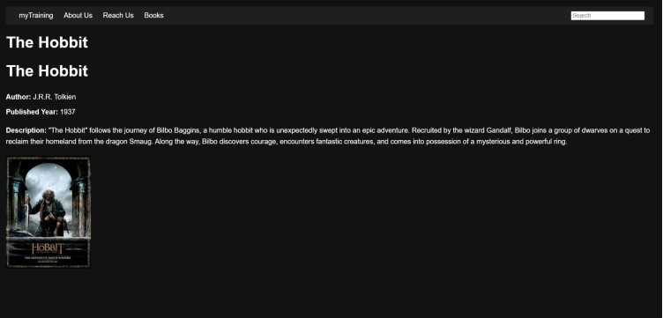

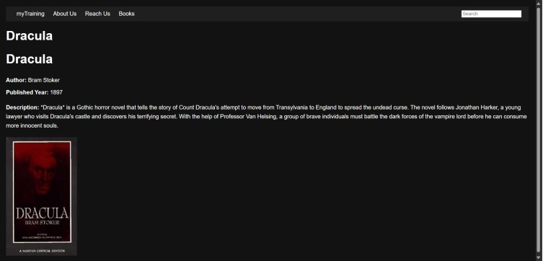

Now create as many pages as required with the book template and book component.

Footer

